Community Eco Ocean Art Project
Ocean Bombing surprize art now until 06.07.19
Final display at the Share, Care & Repair Fair
Saturday 6th July 9am – 5pm  Amphitheatre, Carfax, Horsham  Supported by  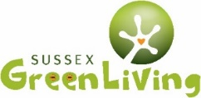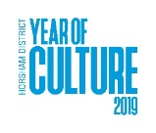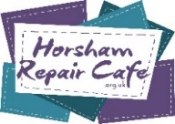 |  | Community message:  Made by: …………………………………………

#OceanBombed Horsham District and beyond!
 | @SussexGreenLiving |  | @SussexGreen |  | SussexGreenLiving

